**Brooklyn torah gazette**

**For parshas devorim 5779**

Volume 3, Issue 48 (Whole Number 145) 9 Menachem Av 5779/ August 10, 2019

**Printed L’illuy nishmas Nechama bas R’ Noach, a”h**

For a free subscription, please forward your request to [***keren18@juno.com***](mailto:keren18@juno.com)

**The Sages through the Ages**

**The Maharal**

**Posen, Poland, around 1520 Prague, Czech Republic 1609**

**Dr Benji Schreiber**

[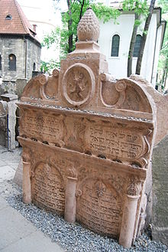](https://en.wikipedia.org/wiki/File:Loew-rabin-tombstone.jpg)

**The tombstone of the Maharal in the**[**Old Jewish Cemetery, Prague**](https://en.wikipedia.org/wiki/Old_Jewish_Cemetery_(Prague))

Rav Judah Loew ben Bezalel, the youngest of four boys. He was born shortly after the Spanish expulsion, Columbus’ discovery of America and the time of the great Kabbalists of Tzfas. He was head of the Beis Din in Posen, Poland then the Rav of Moravia at Nikelsburg, in the Czech Republic.

When he was 60 he became Rav of Prague. His wife was called Pearl and their son, Chaim, was a friend of the Rema. They also had six daughters. Learning He had wide knowledge of philosophy, astronomy and the sciences. He was a prolific writer.

His writings are widely learnt, especially the אריה גור,a commentary on Rashi on the Chumash; and עולם נתיבות which has 33 chapters on 32 different middos; באר הגולה defending Chazal and many others.

One of his great strengths was his focus on the Midrashim, explaining them as allegorical, usually with spiritual and philosophical messages. He explains the spiritual and often rational messages in passages of the Gemara about dwarfs, demons and fanciful beasts.

He was a huge admirer of the Ramban, whom he felt understood had a unique understanding of the secrets of the Torah. His outlook includes drawing a sharp line between Jews and gentiles. He describes the dualism of opposing categories – the matter which is this wordly, related to sin, and temporary; and the form, which is divine, permanent and perfect.

He described the dualism of body and mind; male and female; lack and completeness; Jews and gentiles. He described man as being an upside down tree, with our roots from heaven, and the tefillin serve to root our mind and heart with Hashem.

His writings were major sources of inspiration for Chassidic leaders and for more recent Jewish leaders such as Rav Eliyahu Dessler (1892-1953), Rav Abraham Isaac Kook (1864-1935) and Rav Yitzchok Hutner (1906- 1980).

Rav Hutner said that the Maharal wrote kabbalistic ideas in nonkabbalistic language, .נסתר בלשון נגלה The Golem A famous legend relates that the Maharal made a Golem – a kind of strong obedient mouthless robot made of clay.

However, the first mention of this myth was some 200 years after he died. Prague As a great leader of the city Prague, he is still celebrated by the city, and a public statue of him stands at the City Hall.

In 1592 he had an audience with Rudolph II, Caesar of the Holy Roman Empire, who apparently was interested in Kabbalah! He fought against blood libels. He rebuked those who give semicha to rabbonim who are not fitting; wealthy people who were not generous; and strongly recommended doing chazara on learning.

The Altneuschul, built in 1270, still stands and is Europe’s oldest active shul. He was an educationalist. He argued against children progressing from Chumash with Rashi directly to Gemara and Tosafos. He promoted the wide learning of Mishna, lashon hakodesh and Dikduk.

His best known talmidim were Rav Yom Tov Lipmann Heller, author of the Tosafos Yom Tov on the Mishna, and Rav David Ganz, author of Tzemach David on Jewish and general history.

Descendents include Rav Schneur Zalman of Liadi (1745-1812), founder of Chabad chassidus and Rav Nachman of Breslov.

*Reprinted from the Parashat Mattot-Masai 5779 email of Oneg Shabbos (London, United Kingdom)*

**The Shmuz onParshas Devarim**

**Man: Preprogrammed**

**For Greatness**

**By Rabbi Bentzion Shafier**

**Founder of TheShmuz.com**

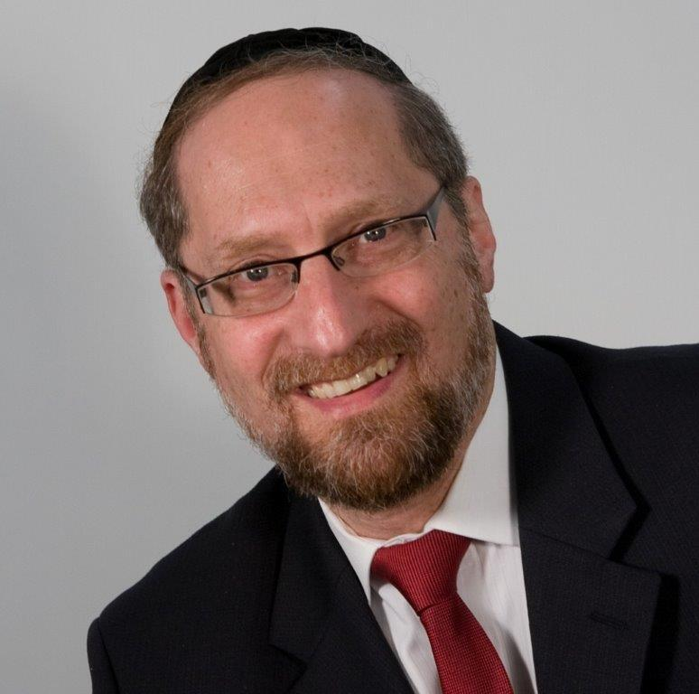

Before the makkah (disease) Hashem prepares the refuah (cure). Within last week’s haftarah warning us about the impending doom, we find a message of hope and salvation.

“The ox knows its owner; the donkey the stall of its master; Yisrael doesn’t know, My nation doesn’t contemplate.”– Yeshaya 1:3

Yeshaya HaNavi began the rebuke of his nation with these words.

Rashi explains what he was saying. The ox doesn’t change its nature. It doesn’t say, “I will no longer plow.” The donkey doesn’t say, “I will no longer haul loads.” Each animal follows its nature, unquestioningly doing what it was created to do. The *Klal Yisrael*, however, is different. You have veered off course and changed your ways. And so, you are lower than the animals created to serve you.

**A Horse and Rider**

This Rashi is difficult to understand. When a man mounts a horse: the man might weigh 150 pounds; the horse might weigh over 2,000 pounds. Yet, the man commands the horse to ride, gallop, turn and stop. And the horse obeys. Why does the huge, powerful horse submit to the will of the little, weak man?

The reason is because that is the *nature* of a horse. Its instinct is to obey. It doesn’t think about it. It doesn’t decide to yield. Built into the very being of the horse is a temperament of subservience to its master.

Man, however, wasn’t constructed that way. Man has conflicting wishes and desires. Man has forces pulling him in competing directions. So how can Rashi compare the nature of a beast, which was created to comply, to that of man, which is so different?

**The Nature of Man**

The answer to this question is based on a more focused understanding of human nature:

The *Chovos Ha’Levovos (Sha’ar Avodas Elokim*) explains that HASHEM created man out of two distinct parts: the *Nefesh Ha’Sichli* (Soul) and the *Nefesh Ha’Bahami (Animal Instincts)*. The *Nefesh Ha’Sichli* comes from the upper worlds, and so, it only wants to do that which is right and proper. It only wants to serve HASHEM and accomplish great things. Its very nature is to strive for perfection.

The *Nefesh Ha’Bahami* on the other hand, is shaped by base instincts and desires. Much like any animal in the wild kingdom, man was preprogrammed with all of the impulses and drives needed for his survival. This part of man hungers for things. It doesn’t think about consequences or results. It can’t see into the future. It is made up of hungers and appetites.

Man is a synthesis, – a perfect balance between two competing forces. If he chooses to listen to his pure *nefesh*, he grows and accomplishes, reaching his potential and purpose in Creation. If he chooses to listen to his animal instincts, then he destroys his grandeur and majesty, becoming lower than even the *behaimah*. What we know as free will is this ability to choose which of his natures he will listen to.

**Man is Preprogrammed for Greatness**

This seems to be the answer to this Rashi. Man is preprogrammed for greatness. Half of man’s personality is screaming out for meaning, purpose and greatness. There is a powerful instinct within him that only desires that which is proper. If man follows that side of his inner nature, he is pulled towards perfection. But that is the point; the *need* for perfection is built into his very nature.

Deep within him is a hunger to grow, to accomplish, to do that which is noble and great. This isn’t something that he needs to learn; it isn’t something that he needs training in; it is part and parcel of his very being.

For a person to reach anything short of perfection, he must make a conscious choice: he must choose *not to listen* to the pulling of his soul.

And so, Yeshaya rebuked his nation, “Being good isn’t foreign to your nature. Following the Torah’s ways isn’t something that is imposed upon you — it is built into your essence. If you have veered off, then you have rebelled against your very nature. You have subverted the pull to greatness that dwells within your heart. And in that sense, you are lower than the animal kingdom, because animals obey the nature that HASHEM put into them.

May we learn to recognize the mercy of HASHEM, even while he warns us of what will be, he prepares us for the return.

May we learn to listen to that Voice inside, and quickly end this long exile, once again taking our place as the Exalted Nation—HASHEM’s Chosen People.

*Reprinted from this week’s website on TheShmuz.com This is an excerpt from the [Shmuz on the Parsha book](https://theshmuz.com/product/shmuz-on-the-parsha-book/).*

**Why Did G-d Allow the**

**Holy Temple to be Destroyed**

**From the Talks of the Lubavitcher Rebbe**

**Rabbi Menachem Mendel Schneerson, Zt”l**

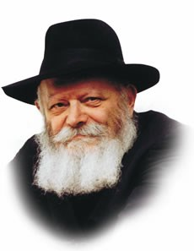

The Shabbat before Tisha B'Av is called "Shabbat Chazon" (vision), for on that day, as Rabbi Levi Yitzchak of Berditchev explained, a glimpse of the Third Holy Temple is given to every Jewish soul, affording it strength and sustenance. Following the week's regular Torah portion (Devarim), the "Vision of Isaiah," a prophecy about the Temple's destruction, is read in the synagogue. Oddly, the word "vision" is used in connection to both the destruction of the Temple and its rebuilding.

About the destruction, our Sages declared, "A lion (Nebuchad-nezzar) came in the month whose sign is a lion (Av) to destroy Ariel ('the lion of G-d'--the Holy Temple), so that a lion (G-d) will come in the month whose sign is a lion and build Ariel." Once again we find the same word--"lion"--referring to both the destruc-tion and the rebuilding of the Temple. What can we learn from this?

In order to understand the connection between the two, let us examine the true nature of the destruction. Our Sages explain that G-d Himself observes the Torah's 613 mitzvot. But if so, how could He have destroyed His Holy Temple, when we are expressly prohibited from razing a synagogue or place of worship? It is also forbidden to wantonly destroy an object of value. Why, then, did G-d allow His dwelling place on earth to be demolished?

One cannot explain the destruction and the subsequent 2,000- year exile by saying that the Jews lost their right to the Temple because of their misdeeds, for instead of destroying the Temple, G-d could have hidden it away as He did the Sanctuary, for such a time as the Jews would merit its return.

Rather, the only instance in which it is permissible to tear down a synagogue is when one wishes to build an even more magnificent edifice on the same site. It follows that the destruction of the Holy Temple also fell into this category. The Second Temple was destroyed only because G-d wanted to build the Third and most exalted Holy Temple--the one that would stand for eternity.

The inner purpose of the destruction, therefore, was solely to rebuild. That is why the Midrash relates that "the redeemer of Israel" was born at the moment the Temple was destroyed: from that moment on, the true objective of the destruction--the Redemption and the building of the Third Holy Temple--could begin to be realized.

It is for this reason that our Sages used similar words to refer to both the exile and the redemption, for just as the Temple's destruction was an integral part of its rebuilding, so, too, is the exile an integral part of the Final Redemption and the coming of Moshiach, may it happen speedily.

*Reprinted from the Parashat Devorim 5753/1993 edition of L’Chaim Weekly (Issue #275), a publication of the Lubavitch Youth Organization in Brooklyn, NY.*

**Rav Avigdor Miller**

**On Art as an Ideal**

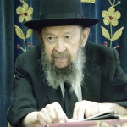

**QUESTION**:  If artwork is a waste of effort then why did Hakodosh Boruch Hu give some people that talent? Doesn't that demonstrate that He wants it to be utilized?

**ANSWER:** And the answer is - people must make a living. So if you're capable of earning a *parnasa* from artwork, so that's your answer. As a result of your artwork you'll be able to send your children to *yeshivos* and you'll support Torah institutions.

Or it may be that some of your artwork may be used for *mitzvos* like making ornamental decorations for *mitzvah* purposes; could be. Other *mitzvos* too; you can do good things with that talent. But what I said was that in itself, art for the sake of art, is considered a waste of effort.

Just because someone has a talent to paint or to draw, does that make it noble?! It's like saying, let's say a person has a talent for computers. So therefore will you say that it should be his ideal in life to sit all of his life and tinker with computers?

No; his talent should be used to earn an honest livelihood, and maybe he'll retire in due time to go into a kollel before he gets too old. And even while he's working, he can make a good parnasa that allows him free time to sit and learn as much as possible. So therefore he's utilizing it.

But it doesn't mean that tinkering in computers is in itself an ideal existence. It doesn't mean that it's an ideal for him to spend his life punching keys just because he's good at it. It's not necessary to say that.

As much as you see that people have certain talents, that doesn't mean that the talents are ideals in themselves.

Here's a man who's an expert barber, so that means that all his life he has to be a barber? It means that his ideal in life should be to give good haircuts? It's no *aveirah* of course if you're a barber, and you can shave peoples' heads *l'kavod shabbos* or *l'kavod* *yomtiv*. And you're careful not to use a razor blade on their *payos*, and so on. Certainly it's a good thing, but it doesn't mean that barbering itself is an ideal.

People have certain talents, so they have to do what they can to use them for the ultimate service of Hashem.

*Reprinted from the July 26, 2019 email of Toras Avigdor (Tape #592)*

**Rabbi Berel Wein on**

**Parashat Dvarim**

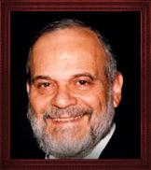

This final book of the five books of the Torah is the great oration of Moshe at the conclusion of his 40 years of leadership and service to G-d and the Jewish people. In it he reviews the events of that period and his observations and comments regarding those events and the behavior of the people of Israel during those decades of miraculous existence in the desert of Sinai.

The underlying question that this book and this week's reading of the Torah raises is why it’s necessary for us to hear the entire story once again. There is no doubt that the Torah, being the word of G-d so to speak, has accurately portrayed the events and details that occurred during this last 40 years of the lifetime of Moshe. So, why the repetition and expansion of the story and why does the Torah include the comments and descriptions of Moshe that at times seem to be in variance to the original narrative as it appears in the previous books of the Torah?

The predators of biblical criticism have always pounced on these seeming discrepancies in order to prove that somehow our holy Torah was produced by committee and various personages over many generations.

The survival of the Jewish people, as outlined in this book of the Torah that we have just begun to read, gives factual denial to such theories. It is inconceivable to think that Moshe himself would not be aware of the differences in the text that he himself is presenting as the word of G-d to the Jewish people. There is a lesson to be learned here as always from every biblical narrative and statement.

We are all aware that reality with strict accuracy is one thing while the perceptions and understanding of those very events is a completely different matter. The Torah describes the events that occurred before the death of Moshe in accurate real detail.

These are the events and facts as they occurred and to which Heaven, so to speak, testifies. But the Torah also teaches us that these were the impressions and understanding of those events by human beings – by the greatest of human beings, our teacher Moshe.

The Torah wishes to make clear to us the difficulty of achieving absolute truth and reality in our world. Everything that we see and believe is always refracted through our own life experiences and personal emotions. That is why no one always shares the same opinion regarding issues, personalities or events in our lives.

The Talmud teaches us that if there are two witnesses to an event that come to testify in a Jewish court and agree to every detail as to what they saw, we immediately suspect them to being false witnesses and poor jurors.

So, the Torah allows us a peek into the soul and mind of Moshe and to reflect on how he saw the events of his lifetime and the story of the 40-year sojourn of the Jewish people in the desert of Sinai. It is always wise to understand the perception of others when we decide on a course of action no matter how convinced we are that we see it correctly and accurately.

*Reprinted from this week’s website of Rabbiwein.com*

**Preserving Man's Dignity**

**By Rabbi Eli J. Mansour**

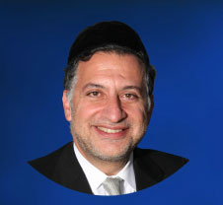

The first verse of Parashat Devarim lists the names of several places where Moshe spoke to Benei Yisrael.  However, as Rashi observes, these places do not actually exist; there are no locations called "Mol Suf," "Lavan" or "Di Zahav."

In truth, Rashi explains, these terms subtly allude to the occasions when Benei Yisrael sinned against G-d during their sojourn in the wilderness. "Mol Suf" refers to their protests at the Yam Suf, where they berated Moshe for leading them out of Egypt; "Lavan," which literally means "white," hints to the incident when they complained about the manna, referring to it as "this white stuff"; and "Di Zahav" refers to the gold used in the fashioning of the golden calf.

Moshe began his final address to the people by making indirect reference to their sins over the last forty years.  Even as he sat down to administer rebuke, to criticize the people for their rebellious conduct, he ensured to do so gently and respectfully, in a manner that would preserve their dignity.

Very often, when we offer criticism, we do so without restraint, chiding and humiliating the individual for his mistake.  Moshe teaches us that criticism must be spoken softly and delicately, with utmost respect.  Even somebody who committed a wrong, even a sinner, deserves our respect and his dignity must be preserved.

This lesson that emerges from the very first verse of Parashat Devarim is perhaps one of the reasons why this Parasha is always read on the Shabbat preceding Tisha B'Av. The Second Temple was destroyed because of this very issue – the people's failure to treat one another respectfully.

This problem reached its peak, perhaps, in the famous story of Bar Kamtza, who was mistakenly invited to a party hosted by somebody who despised him. The host approached Bar Kamtza and told him to leave, and Bar Kamtza pleaded to be allowed to remain rather than suffer humiliation. But the host insisted, and even after Bar Kamtza offered to pay for the entire feast to be allowed to remain, the host had some of the guests physically expel Bar Kamtza from the building.

The Gemara tells that Bar Kamtza decided to avenge his humiliation by bringing false reports to the Roman authorities that Jews had planned a revolt. These false reports triggered the Roman government's campaign against the Jews that ultimately resulted in the Temple's destruction.

Bar Kamtza was clearly a wicked man; he was prepared to endanger the entire Jewish people by spreading false rumors.  And yet, G-d allowed his efforts to succeed because of the humiliation he suffered at the hands of his fellow Jew. We are enjoined to show respect to all Jews, regardless of their level of observance, and even to sinners. In fact, after Bilam was scolded by his donkey, G-d killed the donkey so as to spare Bilam further humiliation. Even Bilam, wicked and corrupt as he was, deserved a sense of dignity.

All the more so, then, must we exercise extreme care when speaking to good, decent people. Even when we must offer criticism, we must ensure to spare them embarrassment and to maintain their respect and dignity. As Moshe teaches us, we must make every effort to criticize softly and respectfully, in a manner that does not cause any humiliation or discomfort, and in this way we will correct the mistake that led to the destruction of the Bet Ha'mikdash and so many centuries of bitter exile.

*Reprinted from this week’s website of the Edmund J. Safra Synagogue in Brooklyn, NY.*

**18 Ways to More Effective**

**Prayer (Part Two)**

**By Rabbi Moshe Meir Weiss**

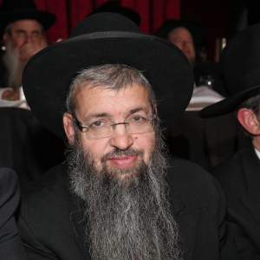

Last week, we introduced the theme that the national Jewish profession is prayer. As Rashi puts it, it’s our umnos, our craft. As such, we will now embark on a crash course on many of the skills necessary to become a professional davener to Hashem.

1. The Gemora teaches us, “Hamispalel b’ad chaveiro v’hu tzoruch l’oso dovar, hu ne’ene techila – One who prays on behalf of someone else and he needs what he’s praying for as well, Hashem will answer his needs first.” This teaches us that when we pray for health, for wealth, for shidduchin or nachas, we shouldn’t just pray for ourselves. We should have our relatives, friends and neighbors in mind as well. This is why most or our prayers are written in the plural. Slach lonu – forgive us, refa’einu – keep us healthy, and shma koleinu – listen to our voices. Hashem gives special attention to a prayer when it isn’t selfish.

One can start practicing this skill utilizing small steps. First, make sure you always pray for your spouse. You should train yourself never to voice a prayer without your mate in mind.

If you’re not married, make sure to include your parents in every one of your prayers. After getting into these good habits, embrace all the people who are davening with you in shul. After that, you can broaden your vision to everyone in your community and then you can set your sights on Eretz Yisroel. Finally, you can train yourself to have a global vision and pray for all of Klal Yisroel.

Here’s a practical example. When you’re davening in shul and you fervently say, “Shma koleinu, Hashem Elokeinu – Listen to our voices, Hashem our G-d,” think to yourself that everyone in shul is asking for something different. One person has a herniated disc, another has a shrewish spouse, yet another can’t afford to pay their tuition.

Utilizing this skill, ask Hashem to honor the different requests of everyone in shul. The Gemora informs us of a bonus and that is when we have others in mind, then Hashem answers us first.

1. Learn how to pray in anticipation. When Iyov experienced his terrible suffering, his three loyal friends asked him, “Hayaroch shu’acha shelo batzur – Did you arrange your prayers before your troubles started?” Or as the Gemora says in Masechtas Berachos, “Al zos yispalel kol chosid l’eis matzoi – For this every pious person should pray towards the time of finding.”

The Gemora explains this to mean that we should pray for things in advance. The Gemora goes on to say that there are over 900 ways to die. We should pray that when it comes our time, we should have an easy death.

The Gemora then takes it a step further: we should pray, “Ad zibula batraisa shalma – That the last clod of earth on our grave should be peaceful.” This is the most extreme example of anticipatory prayer. We should ask Hashem for help that there shouldn’t be a storm on the day of our funeral.

The Gemora is disciplining us in the skill of not being reactionary in our prayer but rather like the Gemora advises us in Masechtas Shabbos, “L’olam yivakeish adam shelo yecheleh – A person should always pray not to become sick.”

Most people only indulge in serious prayer when they have a problem but the smart way to pray is before we have a problem. As we say in Ashrei, “Korov Hashem l’kol kor’ov, l’chol asher yikr’uhu be’emes – Hashem is close to all those who call to Him, to all those who call in truth.”

Rav Avigdor Miller, zt”l, zy”a, would elaborate, it is best to pray in truth and not when you are in need. We need to train ourselves in sim shalom that there should not crop-up any marital problems, and in Atah chonein that we shouldn’t start forgetting things or begin feeling confused, chas v’shalom.

We are just getting started. In the merit of learning how to pray properly, may Hashem bless us with long life, good health, and everything wonderful.

Reprinted from the July 31, 2019 website of Matzav.com

**Alan Dershowitz Says The President Did a Mitzva for Freeing Ronen Nachman**

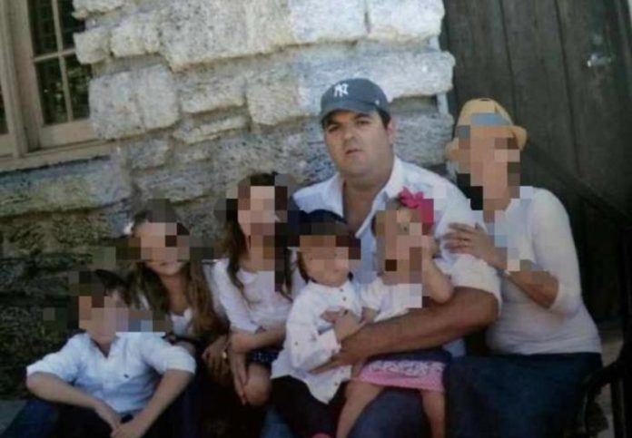

President Donald Trump commuted Monday the sentence of Ronen Nahmani, husband to wife who suffers from Stage 4 cancer and father of five little children, after receiving touching letters from three of them: Ariella, 11, Orel, 10, and Daniella, 8.

Ronen, a religious orthodox Jew and resident of Aventura, Florida, was sentenced in 2015 to 20 years in prison, a maximum punishment for conspiracy to possess with intent to distribute synthetic marijuana.

His wife, Sylvia, told Hamodia “I’m still trying to catch my breath because I’m so overwhelmed, I can’t believe what happened and I’m so grateful.”

“I don’t even have words in the dictionary to describe how grateful I am, how blessed I feel and how I overwhelmed I am with the joy in my heart,” Mrs. Nahmani said.

Famous attorney and staunch Israel supporter Alan Dershowitz, who participated in the efforts to release Nachmani commended the President for his actions.

“What President Trump did was the right thing; he ought to be praised for saving lives and doing a mitzvah.”

*Reprinted from the July 30, 2019 website of Matzav.com*

**The Lubavitcher Rebbe Died**

**25 Years Ago, But His Impact Lives**

**On Across All Jewish Denominations**

**By Sue Fishkoff**

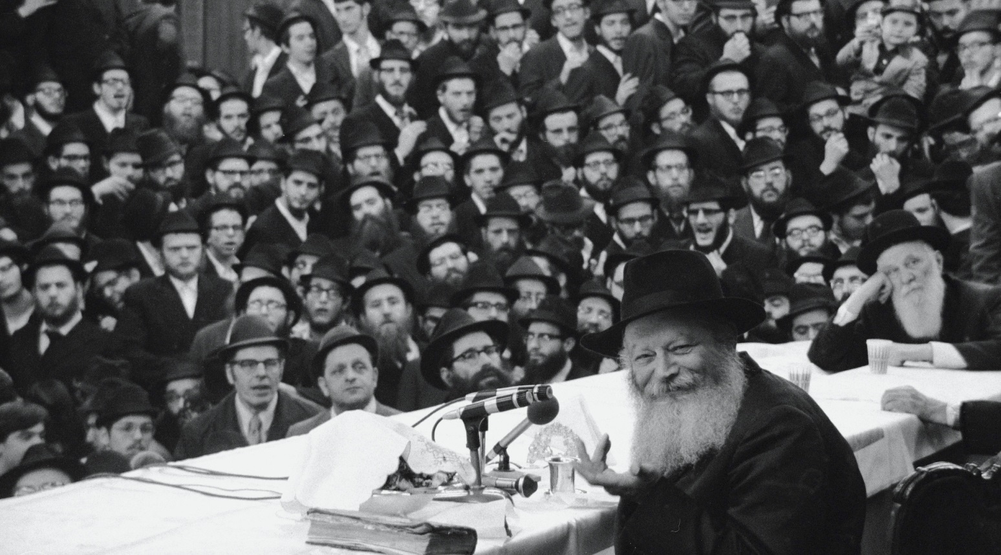

**Rabbi Menachem Mendel Schneerson, at the microphone, shown in New York circa 1975. (Tim Boxer/Getty Images)**

SAN FRANCISCO ([JTA](http://www.jta.org/)) — When the last Lubavitcher Rebbe, Menachem Mendel Schneerson, died in July 1994, I was one of many journalists in the Jewish media who did not see how the Hasidic movement he led could survive, much less thrive, in his absence.

It has, of course. That is due to a number of factors, including routinization and institutionalization, as pointed out by [Samuel Heilman in a recent JTA essay](https://www.jta.org/2019/07/05/opinion/the-chabad-rebbe-died-25-years-ago-heres-how-his-movement-has-survived). His Chabad movement’s enormous network of educational institutions and emissary outposts, put in place during Schneerson’s lifetime, continue the movement’s global work, buoyed by strong infrastructure and the motivation of his followers.

But there is another reason why the Chabad outreach movement in particular continues to grow: It fills a need. If it did not, unaffiliated and searching Jews would not continue to come to Chabad centers, attend holiday and Shabbat celebrations, send their children to Chabad camps or supply the funding that keeps them afloat.

What need does Chabad fulfill, and why aren’t people finding it in the synagogues and Jewish schools they grew up with? That’s what I explored in my 2003 book “The Rebbe’s Army,” conducting interviews with more than 100 largely nonobservant Jews as to why they found Chabad appealing. The same interviews could be conducted today and would yield most of the same answers.

Here’s what I heard, and continue to hear: “Chabad taps into the joy and passion of Judaism for me”; “it makes me excited to be Jewish”; “the emissaries, or shluchim, are welcoming and nonjudgmental, even though they are more observant and Jewishly learned than I am”; “they teach me how to be comfortable in my Jewish skin”; “they make me feel good when I do mitzvahs.”

Many of the Jews who flock to Chabad come with little or no Jewish upbringing. Just spending time with the emissaries and their children provides them an entryway into Jewish practice. Other Jews who support Chabad come from traditional backgrounds, and find the dedication and seriousness they miss and have not found in their mainstream synagogues. Different Jews find different needs fulfilled by Chabad.

When I was researching my book, the Reform and Conservative movements were just beginning to look at Chabad outreach for practices they could adapt to their own needs. Today, 25 years later, most every synagogue says it is warm and welcoming. Adult learning classes abound. Engaging the under-engaged — the mission of Chabad outreach — is now everyone’s mission.

Other Chabad innovations have been widely adopted by mainstream Jewry, from asking men in public places to put on tefillin (now Women of the Wall in Jerusalem asks women to do the same) to putting up Hanukkah menorahs in public spaces. In fact, taking pride in public displays of Judaism, which has grown steadily since the 1970s, first helped Chabad appeal to non-Hasidic Jews and in turn has been encouraged by Chabad’s success.

At the same time, there are many things about Chabad I find troubling, even distasteful. Some of this is part of standard Orthodox Judaism, such as non-egalitarian worship and the belief in the superiority of the Jewish soul. Other things are particular to Hasidism, notably the reverence shown toward an individual rebbe. Chabad Messianism, the exclusion of Israeli holidays from Chabad calendars, the right-wing politics — I don’t like any of it.

None of that, however, detracts from what is enduring and worthwhile: the Jewish outreach. Quite simply, Chabad has changed Jewish lives.

It’s changed mine, in small but meaningful ways. I’m not shomer Shabbos, but now I have a mezuzah on my door. I take care to avoid embarrassing others, a commandment in Judaism that I only learned about through Chabad. Same with visiting the sick and showing up for shivas. Again, standard Jewish teachings that I learned from Chabad.

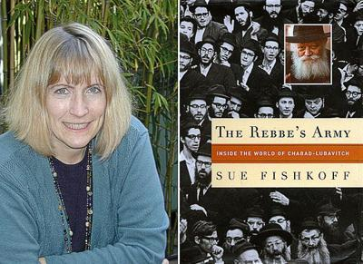

**Sue Fishkoff, author of the 2003 book titled “The [Lubavitcher] Rebbe’s Arm.”**

Two years ago, when my sister Jennifer was dying in a Miami hospital and my parents were driving back and forth every day to their home in Boca Raton, a Chabad rabbi offered them an apartment he kept right next to the hospital for just this purpose. They stayed there for months, for free. Of course, my parents gave him a donation later, but the point was, he didn’t ask. He just gave. Because that’s what a Jew is supposed to do.

That’s what a human is supposed to do.

*Reprinted from the July 16, 2019 dispatch of the JTA (Jewish Telegraphic Agency.)*